New project in Intelliji:

File->New->Project from Version Control

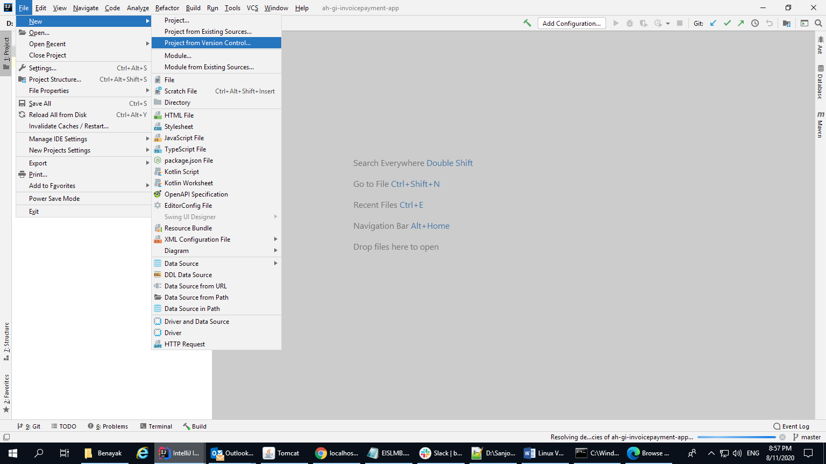

Suppose we are downloading invoice payment app:

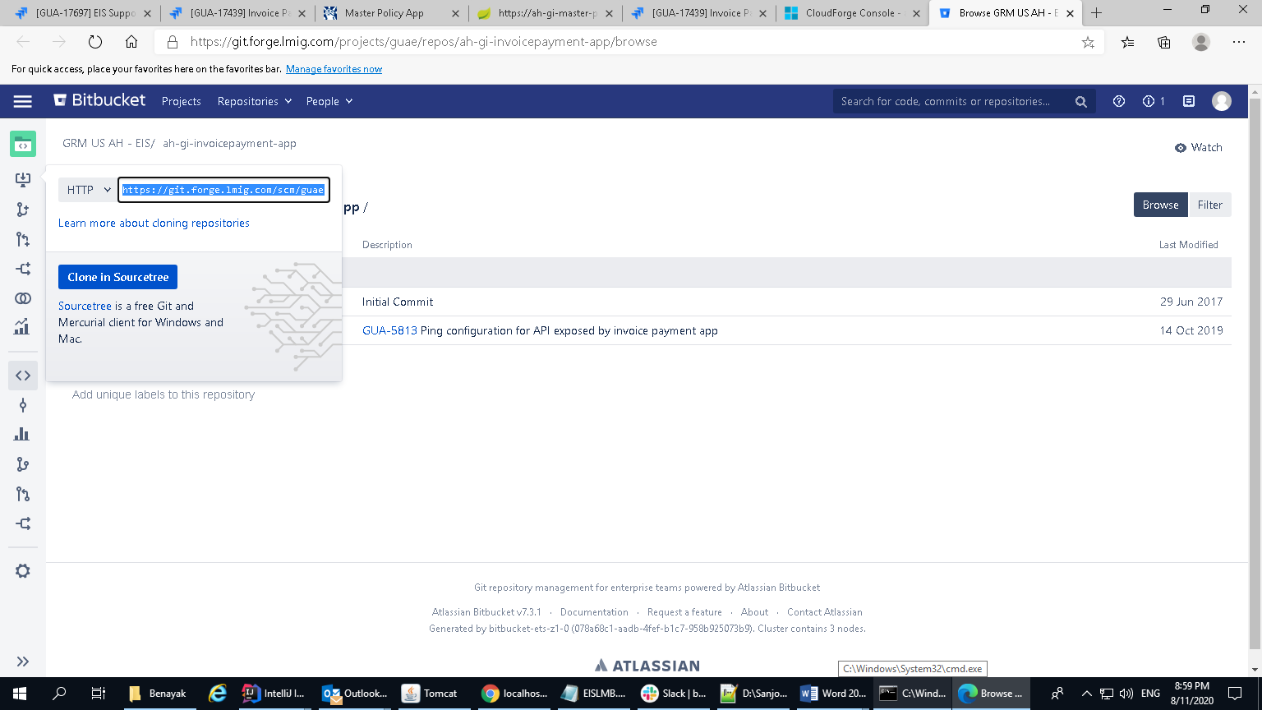

Copy the highleted url and paste it in below box:

<https://git.forge.lmig.com/scm/guae/ah-gi-invoicepayment-app.git>

https://git.forge.lmig.com/scm/guae/ah-gi-invoicepayment-app.git

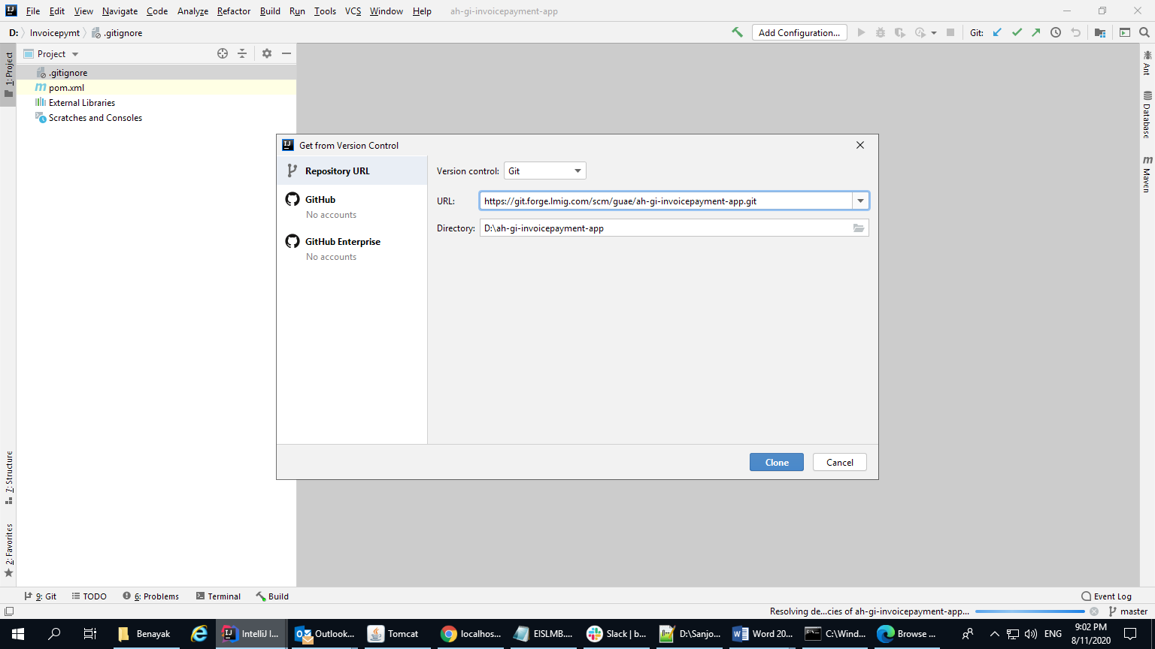

Click on Clone.